Self-Driving Car Project with Neural Networks

Project Title:- Self Driving Car with Driver Drowsiness Detection and Alert System using Python

The Self-Driving Car Project revolutionizes transportation by incorporating neural networks for autonomous vehicle control. This application utilizes advanced machine learning algorithms to process sensor data, recognize road conditions, and make real-time driving decisions. The neural networks' ability to adapt to dynamic environments and diverse scenarios ensures safe and efficient autonomous driving. This project represents a significant stride towards the future of transportation, where vehicles can navigate without human intervention, enhancing road safety and transportation efficiency.

Self-Driving Car Project using Machine Learning, In this project user can upload image or videos to ML model and it will detects road lane, traffic signs and autonomous steering according to curve. Simultaneously it will identify the person drowsiness state and it works on real-time. It is desktop based software developed using tkinter library.

Object detection is essential for self-driving vehicles to comprehend their environment. The
paper proposes an RVnet model which will be used for improving real-time detection efficiency. RVnet blends convolutional and recurrent neural networks to represent spatial connections between video frames. To extract visual data every frame, model will employ a CNN backbone pretrained on ImageNet. These can be fed into an LSTM recurrent layer, which will be able to collect data across frames. We will improve RVnet to recognize items such as automobiles, pedestrians, and bicycles for autonomous driving. The RVnet model classifies detections produced by region proposal networks. By using KITTI, Waymo, and nuScenes dataset, the RVnet model can increase average accuracy. The improved accuracy and fast speed will show RVnet's potential for improving real-time object recognition in self-driving vehicle applications.

- https://www.cvlibs.net/datasets/kitti/index.php
- https://waymo.com/open/
- https://www.nuscenes.org/nuscenes

Intro Real-Time Self Driving System using Deep Learning Project:-
Object detection, or the method of localizing and identifying things in images, is a critical function needed by self-driving vehicles to navigate their surroundings safely. Precisely recognizing items such as automobiles, motorcycles, road signs, people, and so on in real-time offers critical perceptive skills for self-driving cars. Although deep learning has made tremendous progress in object identification, maintaining high precision with low latency remains a problem, particularly in dynamic self-driving settings. This proposal describes research into utilising Recurrent Vision Networks (RVnet) to improve real-time object recognition in self-driving vehicle applications. RVnet trains spatio-temporal abstractions from consecutive input by combining convolutional neural networks (CNNs) with recurrent neural networks (RNNs) (Khan, Lee and Lim, 2023). RVnet models are able to include inter-frame spatial context and dependencies, resulting in improved object identification over single-frame models.

The primary research tasks are as follows: 1) Create an RVnet model designed for reliable and real-time identification with appropriate categories of objects such as automobiles, pedestrians, road signs, and so on in self-driving situations. 2) Test the framework on self-driving vehicle datasets such as KITTI, Waymo, and nuScenes to evaluate efficiency contrary to single-frame baselines. 3) Examine the effect of various RVnet designs and hyper-parameters on identification speed and reliability. 4) Deploy and analyze the model on an embedded system for a real autonomous automobile.

The fundamental approach entails using a CNN backbone for spatial extracting features, adding RNN layers to collect inter-frame data, producing area suggestions, and training the RVnet model for 2 classification and box-bound regression. Extensive studies will assess RVnet settings, improve performance vs. accuracy constraints, and benchmark on public datasets as well as practical test cars.

The goal of this study is to illustrate RVnet's potential for improving real-time object perception for self-driving cars. RVnet offers the ability to enhance detection accuracy without sacrificing inference performance or latency by merging deep spatial feature learning with temporal sequence modeling. This study has the potential to make significant contributions to the development of secure and reliable computer vision algorithms for autonomous vehicles.

Flow Chart of Autonomous Car Driving System :-
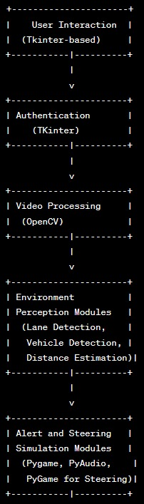

Architecture of Object Detection for Autonomous Driving through Deep Learning:-
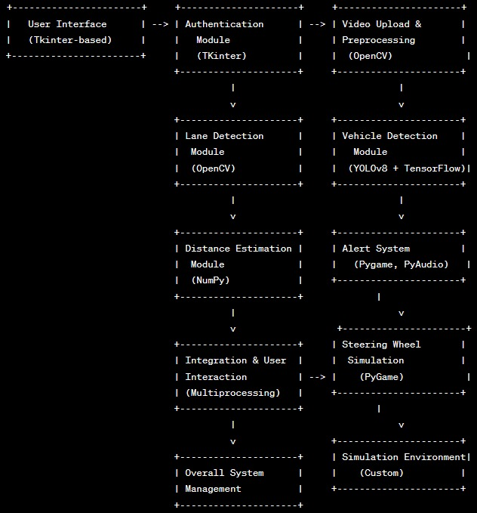

User Interface (Tkinter-based):
Responsible for creating the graphical user interface (GUI).
Built using Tkinter, a Python library for creating GUI applications.
Allows users to interact with the system, including video upload and system controls.
Authentication Module (TKinter):

Manages user authentication and access control.
Implemented using Flask for back-end functionality.
Tkinter is used for rendering the login page dynamically and handling user interactions.
Video Upload & Preprocessing (OpenCV):

Handles the uploading of video files by authenticated users.
Uses OpenCV, a computer vision library, for video processing.
Extracts individual frames from the uploaded video at 30 FPS, which serves as input for subsequent processing modules.

Lane Detection Module (OpenCV):
Identifies and tracks road lane markings within the video frames.
Utilizes OpenCV's image processing and contour analysis capabilities.
Applies Gaussian blur, Canny edge detection, and contour analysis for accurate lane tracking.
Vehicle Detection Module (YOLOv8 + TensorFlow):
Detects and tracks surrounding vehicles in real-time.
Uses YOLOv8 (You Only Look Once) deep learning model for object detection.
TensorFlow is employed for executing the YOLOv8 model and processing the results.
Distance Estimation Module (NumPy):
Estimates the distance to the preceding vehicle for collision avoidance.
Combines the size of detected vehicles in pixels with camera calibration parameters using NumPy.
Geometric calculations are performed to determine real-world distance.
Alert System (Pygame, PyAudio):
Activates visual and audio alerts when the estimated distance to the preceding vehicle is below a safety threshold.
Pygame is used for rendering visual alerts, such as warning icons.
PyAudio plays collision alarm MP3 sounds for audio alerts.
Steering Wheel Simulation (PyGame):

Simulates the movement of the steering wheel based on lane positions detected by the Lane Detection module. Pygame renders the steering wheel sprite using OpenGL transformations.
Enhances user engagement and provides a realistic representation of steering angles induced by lane curvature changes.
Integration & User Interaction (Multiprocessing):
Ensures the concurrent execution of all modules for a responsive real-time simulation.
Multiprocessing is used to manage parallel processing, allowing modules to run concurrently.
Users can interact with the simulation through the Tkinter interface.
Stearing WHeel CNN algorithm Matrics
284/284 [==============================] - 1s 3ms/step
Precision: 0.763170188220263
Recall: 0.8735961242017177
F1 Score: 0.8146581628369097
Accuracy: 0.8735961242017177
Yolo Matrics
Precision: 0.57
Accuracy: 63
F1 Score: 0.59
Recall: 0.53
Yolo Paper: https://www.cv-foundation.org/openaccess/content_cvpr_2016/papers/Redmon_You_Only_Look_CVPR_2016_paper.pdf
Dataset: https://drive.google.com/drive/folders/1zm7VSRCsYHmKqEpZHe-TDNogYEf_pfTp?usp=sharing
Doubts Related to Autonomous Car Driving and Driver Drowsiness and Alert System:-
Question 1: How did you validate the results?
Answer: To validate the results and assess accuracy, we employed a standard practice of splitting the dataset into training and testing sets. The model was trained on the training set, and subsequently, the testing data was utilized to evaluate and validate the accuracy of the model.
Dataset Link: https://github.com/SullyChen/driving-datasets
Question 2: What is your motivation to use this dataset?
Answer: My motivation to use this dataset stems from completing the Self-Driving Car Engineer Nanodegree. Through this course, I gained insights and exposure that motivated me to implement a system using the provided dataset.
https://www.udacity.com/course/self-driving-car-engineer-nanodegree--nd0013
Question 3: How do you ensure the model is not overfitted?
Answer: To prevent overfitting, we implemented several strategies. Firstly, we carefully curated and verified the dataset, eliminating noisy data. Additionally, we utilized a reduced number of epochs during training and employed proper loss computation techniques. Data augmentation was applied to enhance the model's ability to handle diverse scenarios. Furthermore, the incorporation of a dropout layer played a crucial role in mitigating the risk of overfitting during the training process

